Task on Lambda and API
To create function in lambda
objective: to create a function is to run backend code without running the servers or serverless.
prerequisites:
AWS console
Lambda
python language
trigger
step by step process:
first go to aws console—lambda—create a function

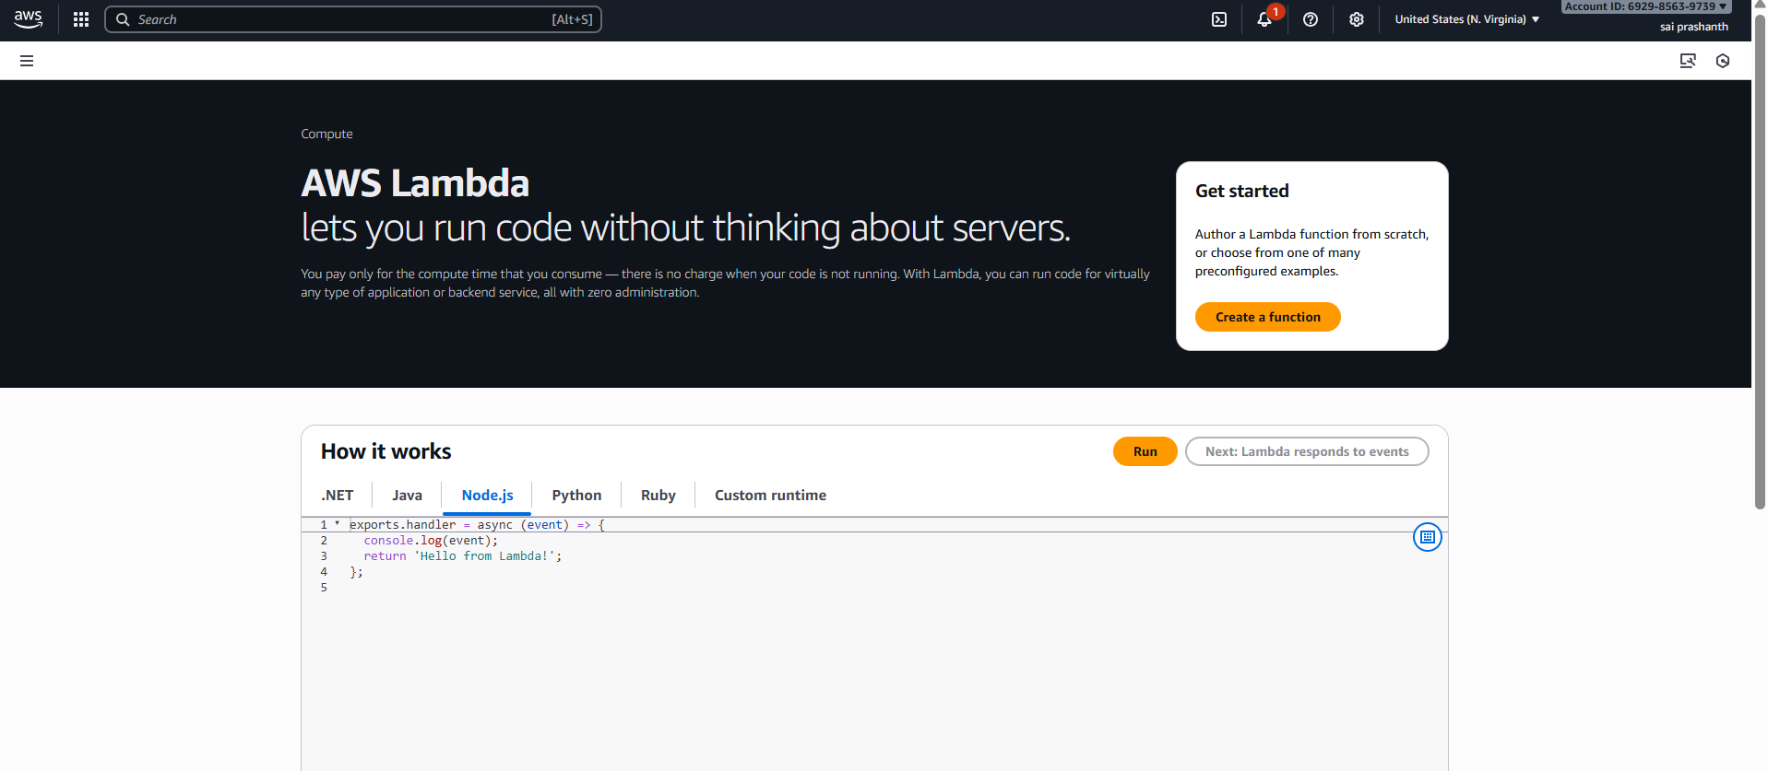
after clicking it, select author from scratch
give one role name
select runtime—python

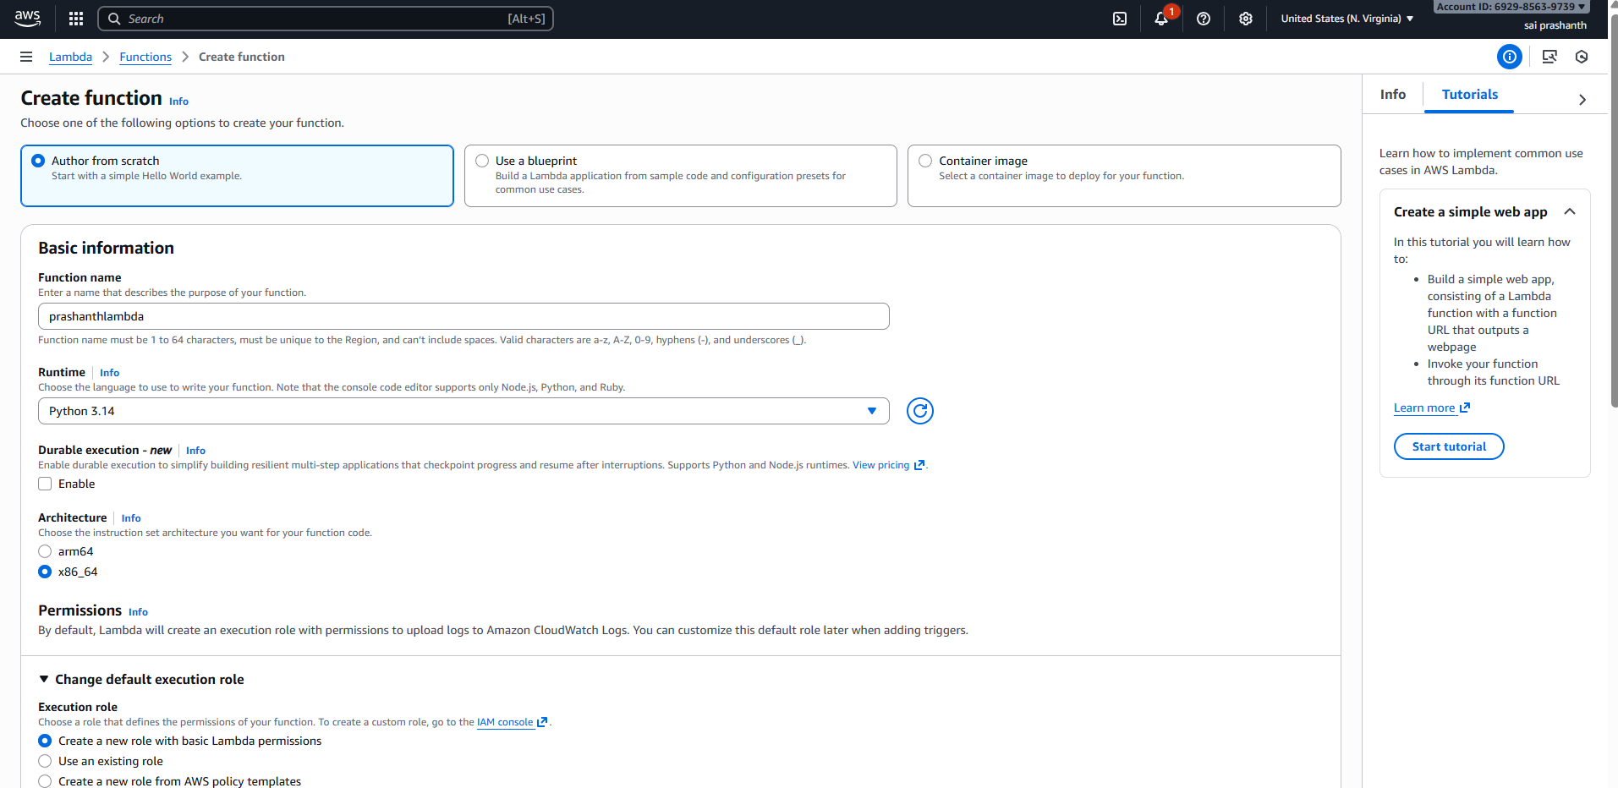
select the execution role----create a new role with basic lambda permissions—then click on create function
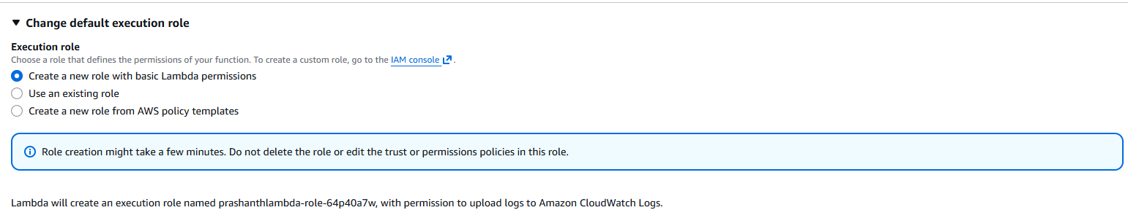
validation:
now the lambda function has been created
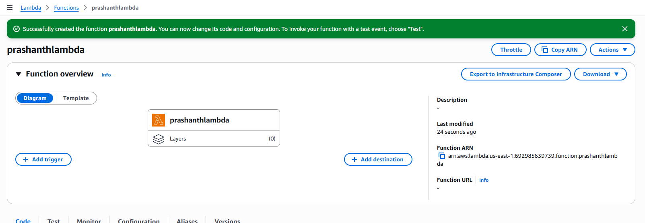

how to check the logs in lambda and to check on cloudwatch
objective: to check the logs in lambda after creating the function
prerequisites:
aws lambda
function
python code
test event
step by step process:
first after creating the function you can see the code default created by aws
next click on test—create one test name---click on test
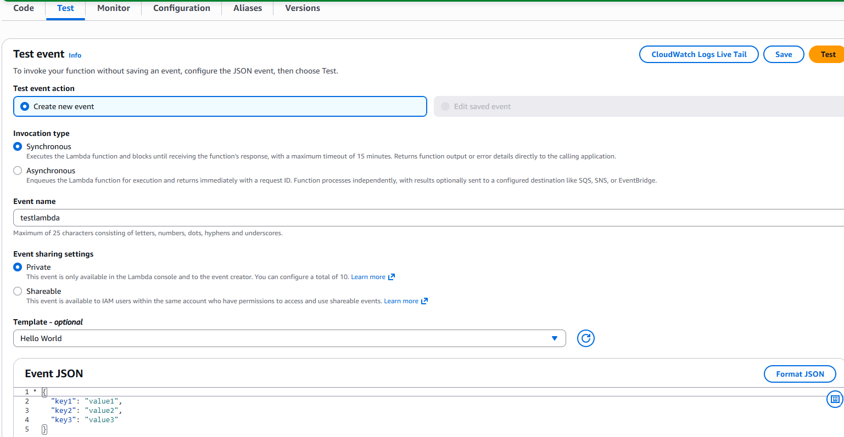
once you have clicked test it has been executed successfully

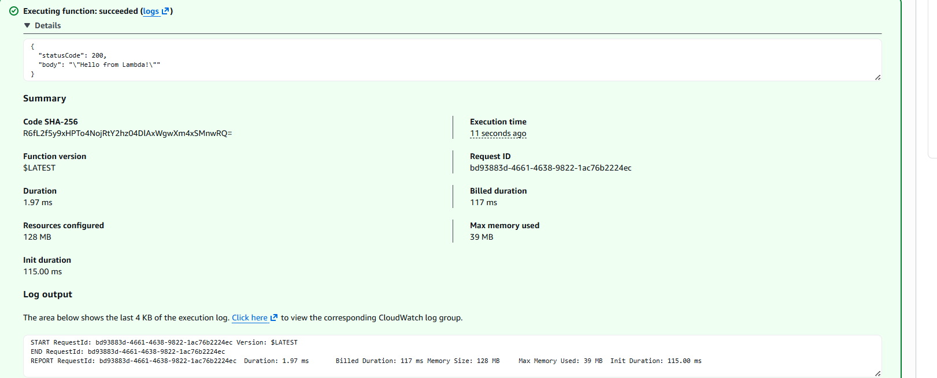
now to check the logs---go to cloud watch---log management—log streams—select the log file and click on that
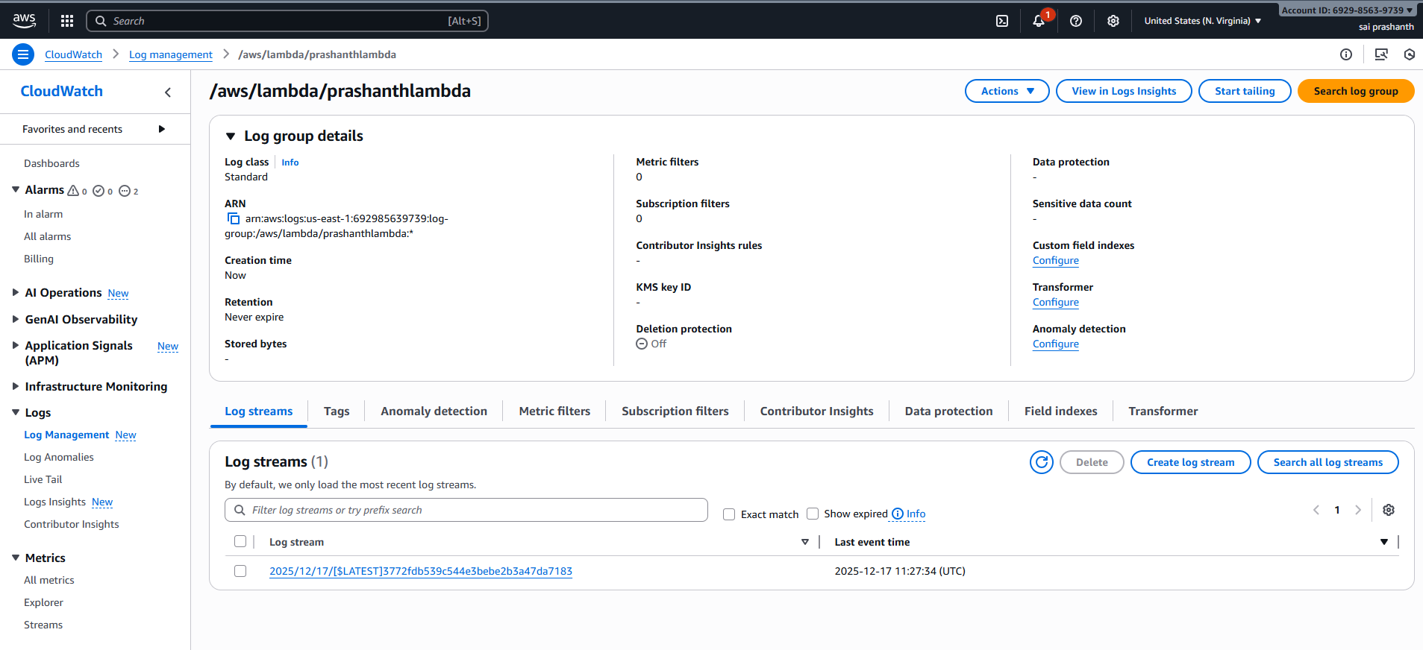
validation:
now you can see the logs has been created in CloudWatch
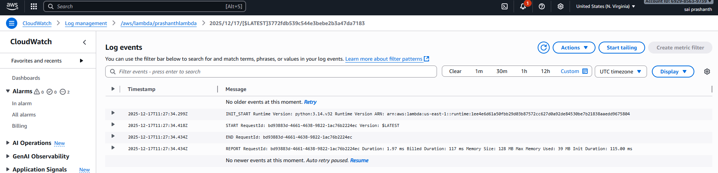

to deploy the code in lambda
objective:
To deploy and execute Python code using AWS Lambda in a serverless environment
prerequisites:
lambda function
python code
step by step process:
first go to lambda console
select your function which have been created—click on the code
you can see default code by aws for your created function
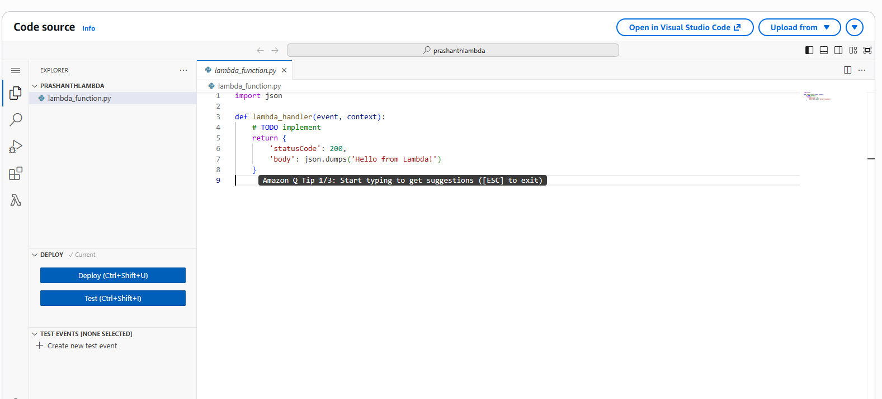
now to deploy one new code
here I added print(“Prashanth from Tirupathi”)
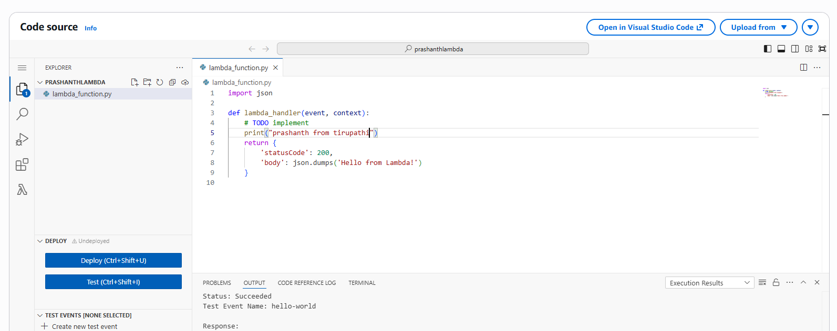
now you can see function has been successfully updated
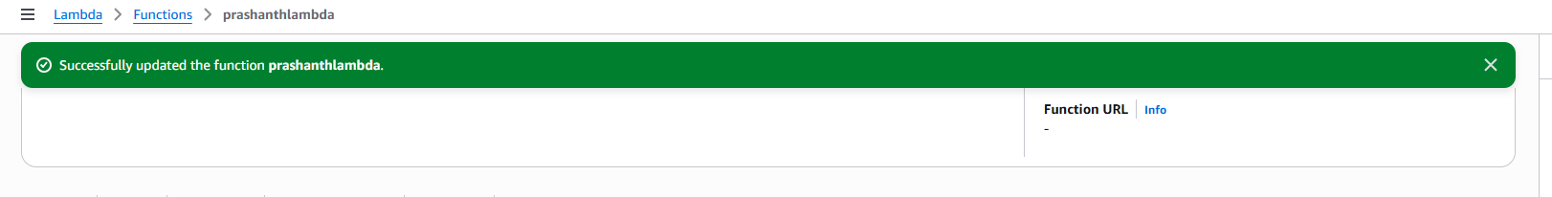
now after updating again, we need to add one test name event and deploy it and click on test
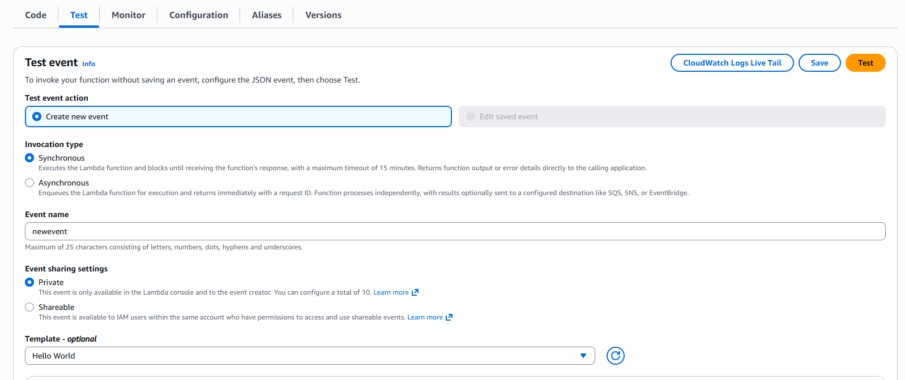
now the test has been existed successfully
you can check in CloudWatch with updated code
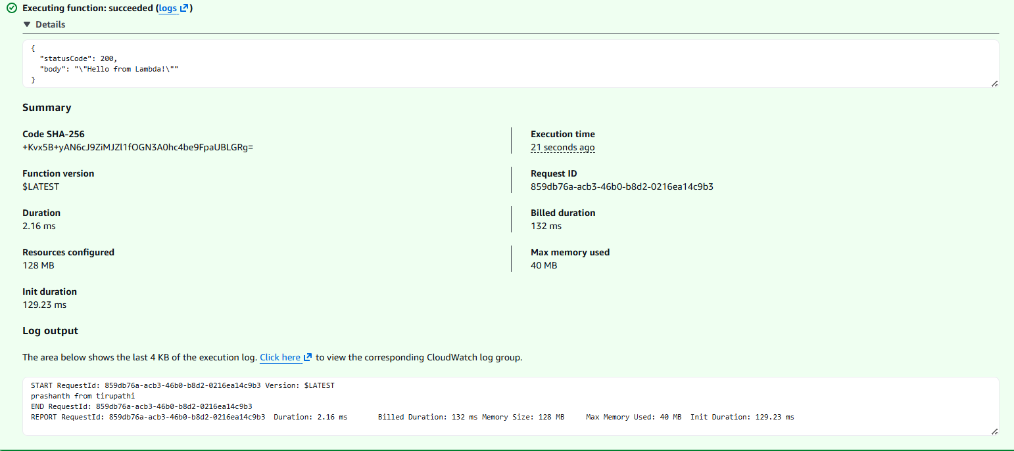
validation:
now you can see the logs in CloudWatch with the updated code
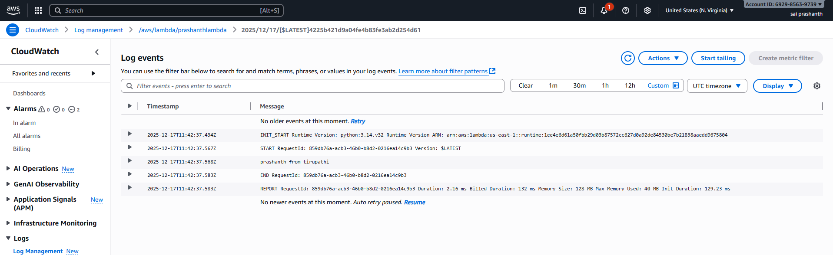

how to connect lambda to S3
objective: to connect from lambda to s3 and to trigger it
prerequisites:
s3 bucket
objective
triggers
step by step process:
first create s3 bucket----upload the object in it
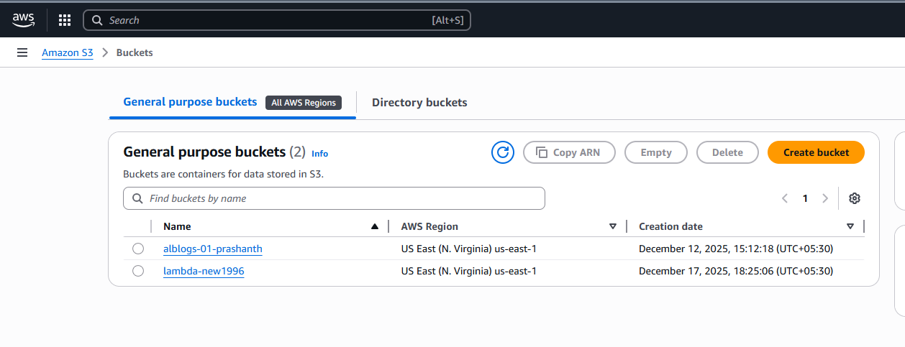
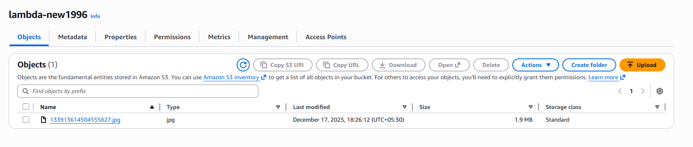
now select trigger in lambda
click on trigger ---select s3---click it
validation steps:
now you can see in triggers list and if you click on created bucket it directly goes to your bucket
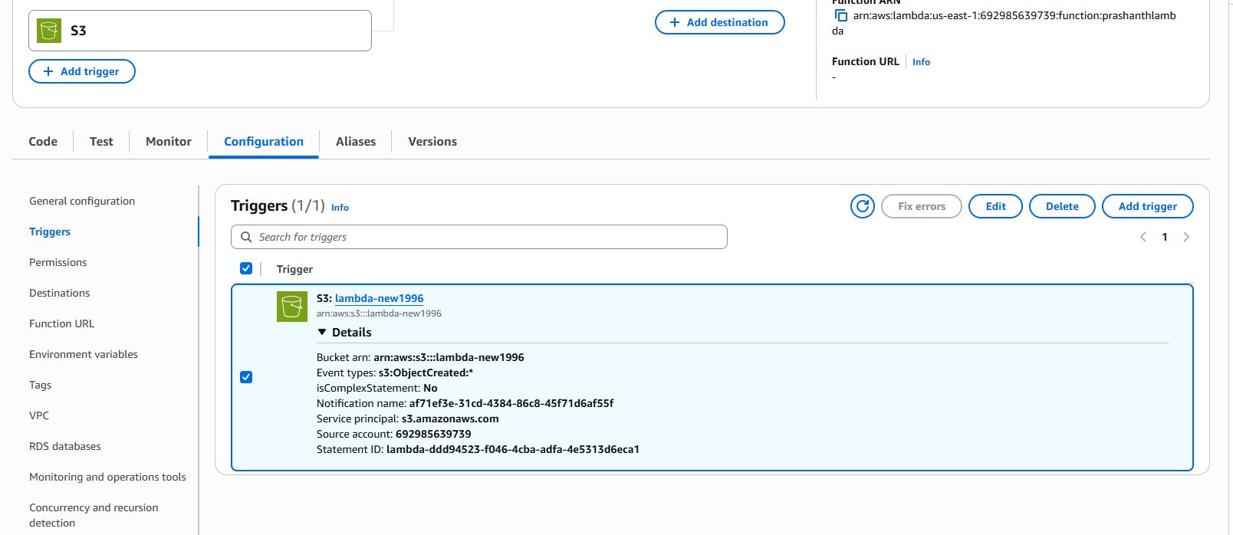
to get the access of s3 you need to add in permissions in iam policy
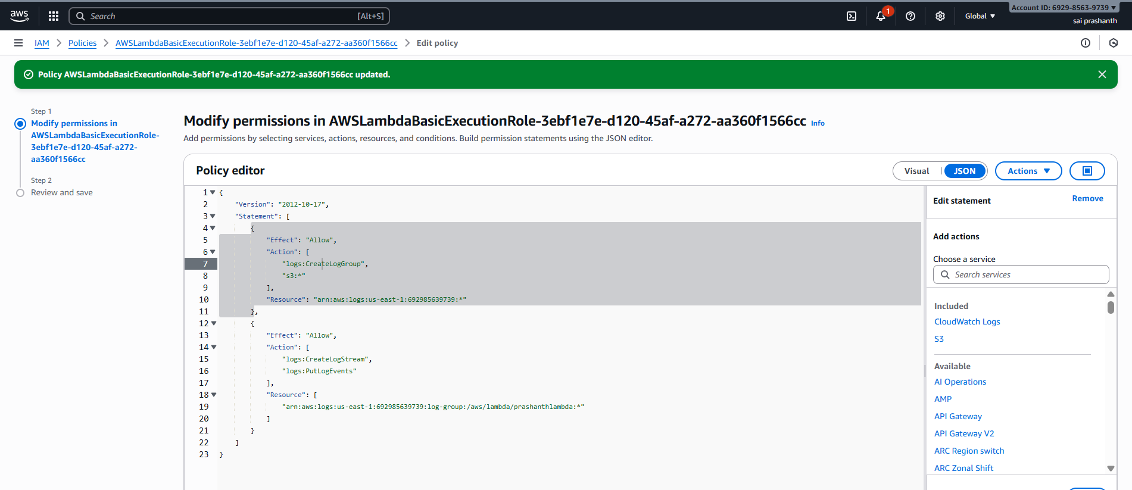
now to check the logs go to cloud watch and check the log groups
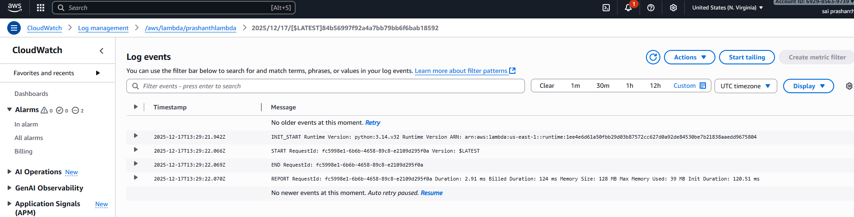
Connecting lambda with API gateway
objective: to connect lambda with API gateway
prerequisites:
aws
lambda
Api
step by step process:
go to Api console—click on create Api
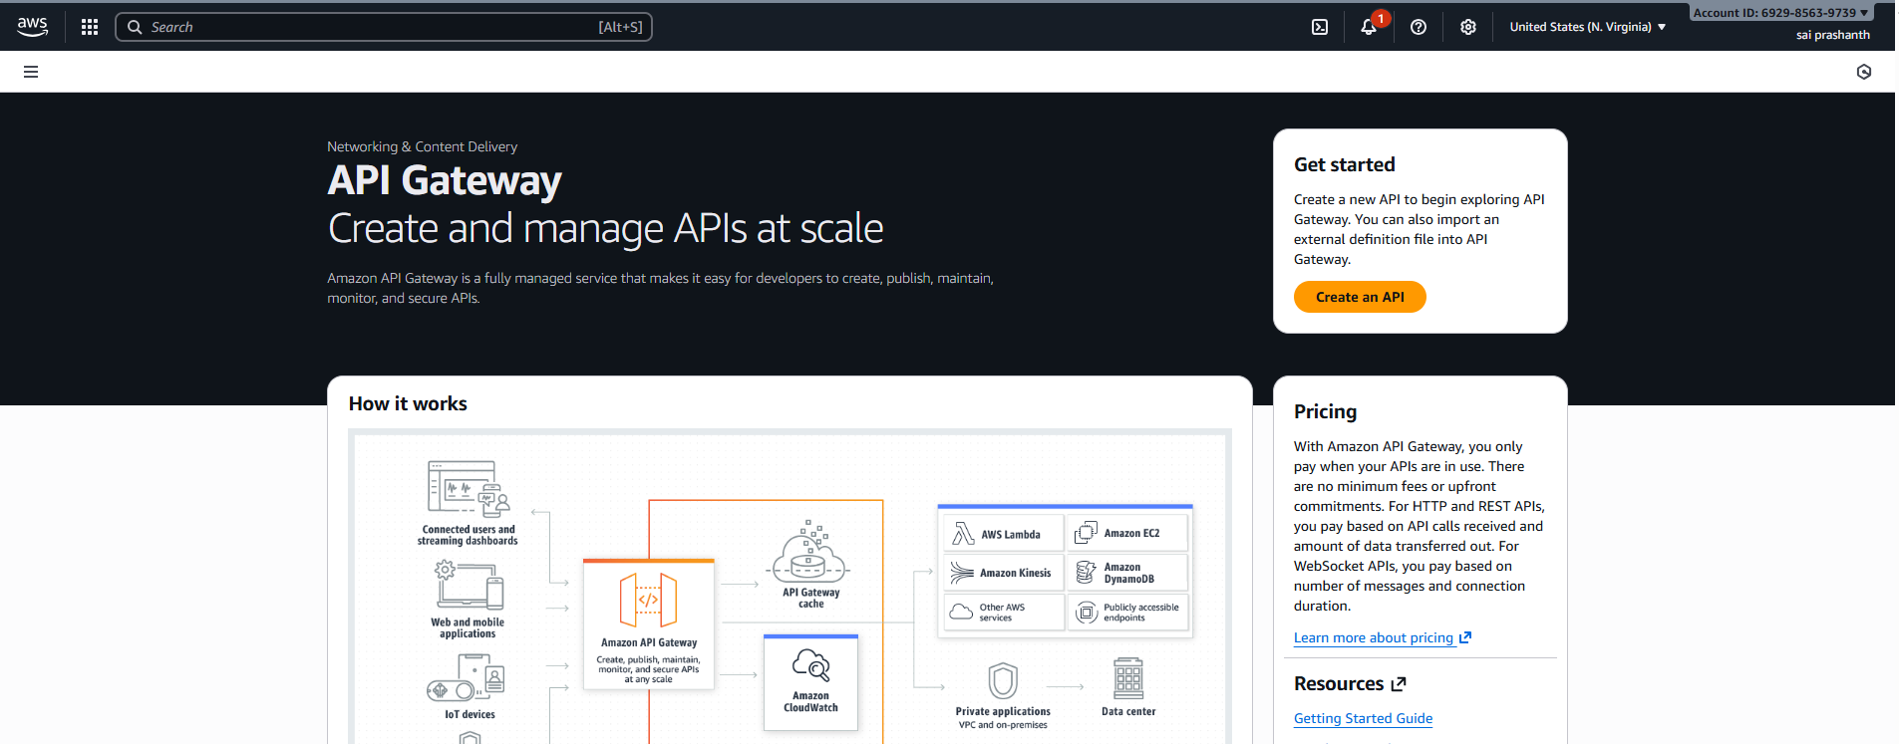
after clicking it---select http api
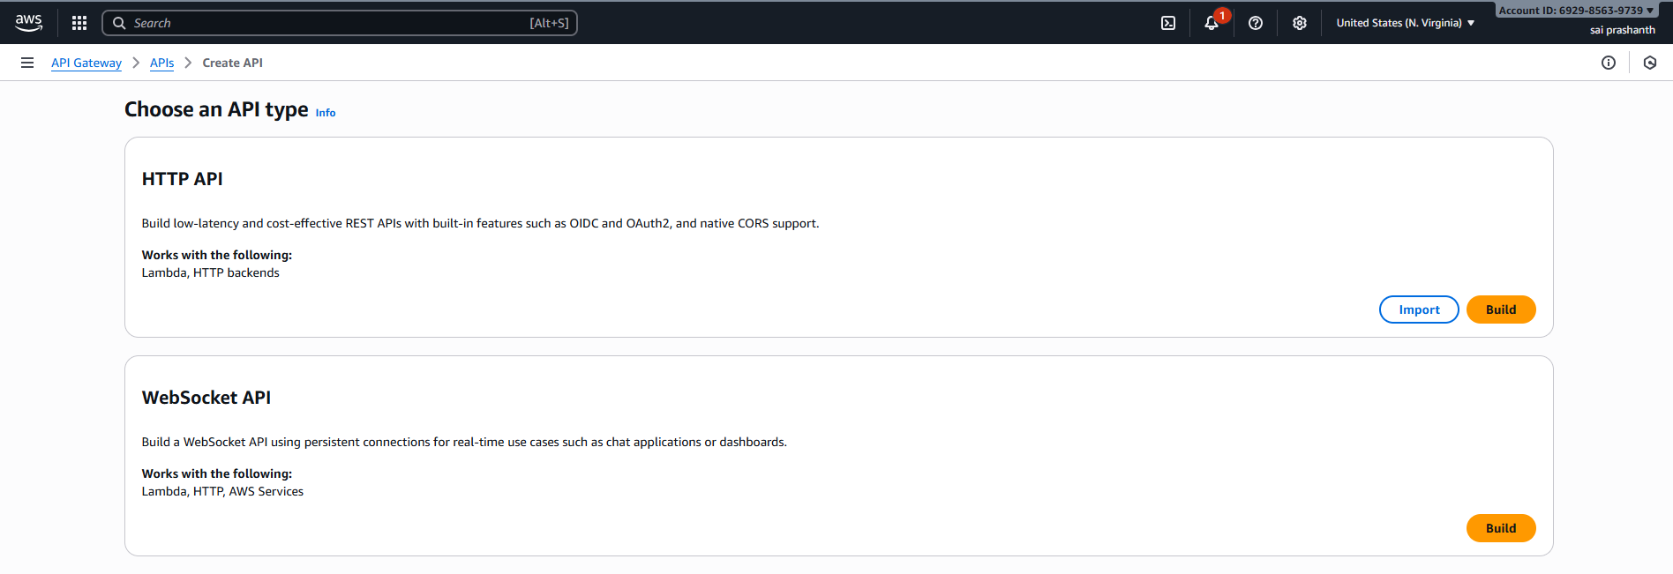
give API name—click on next and click on integrations—select your lambda
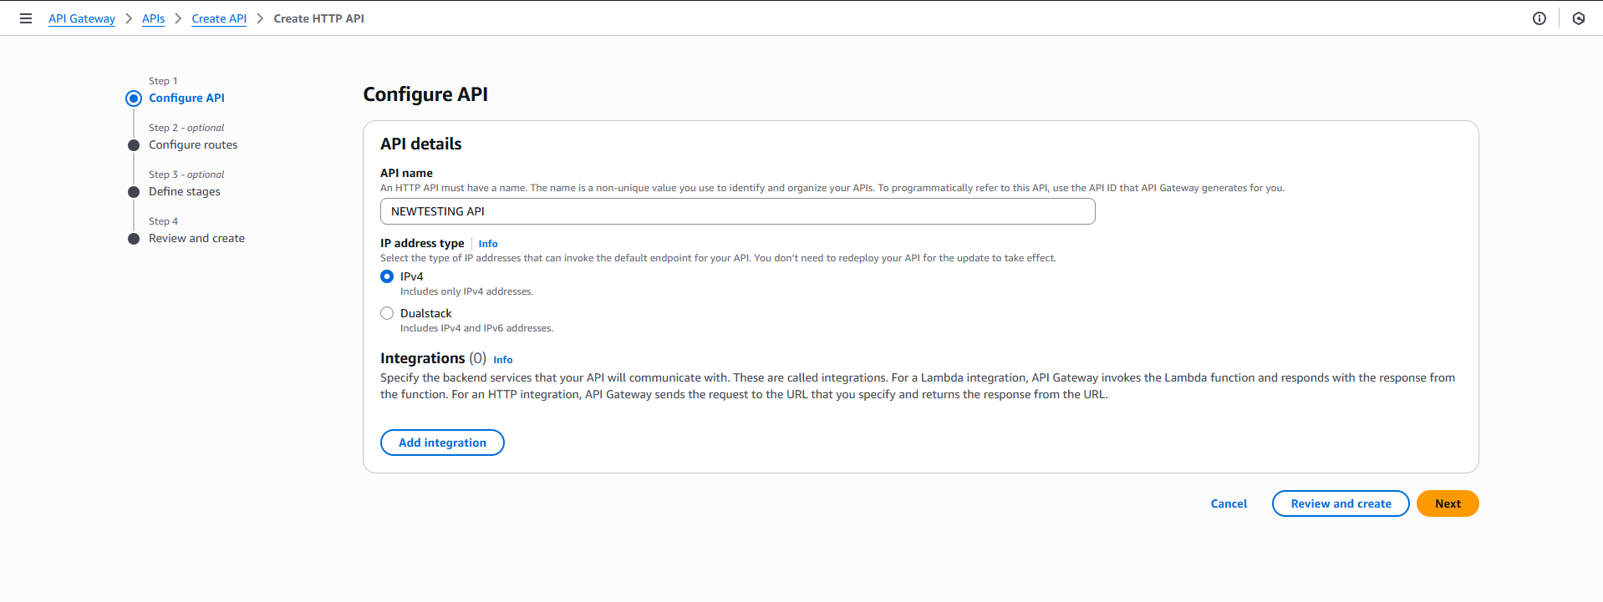
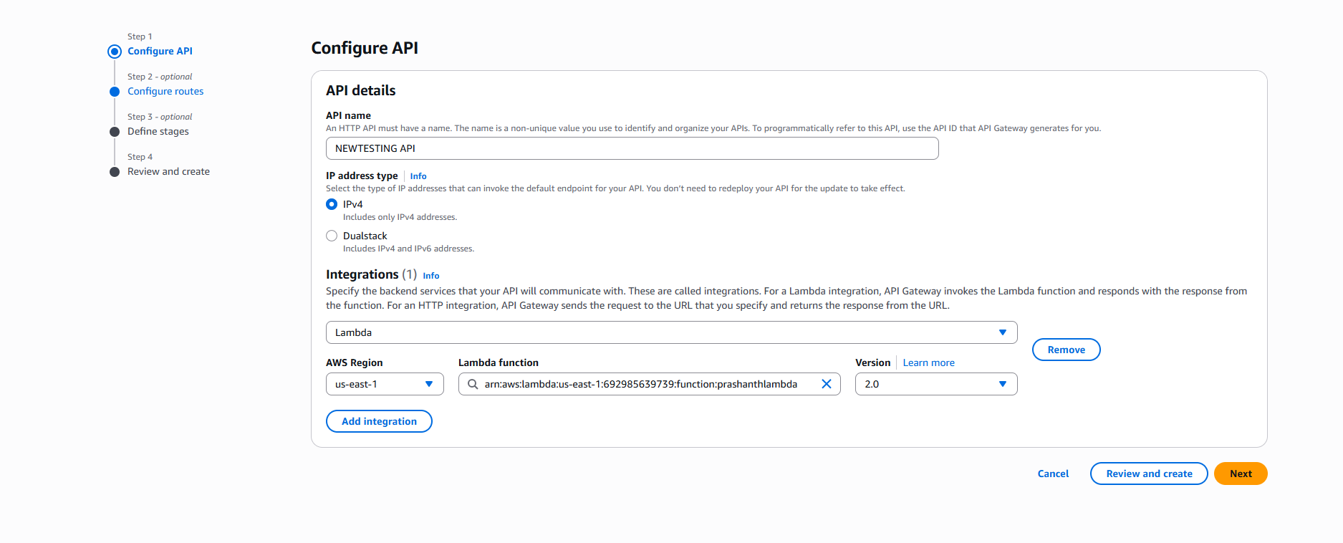
provide the routes as below /hello and click on next---next
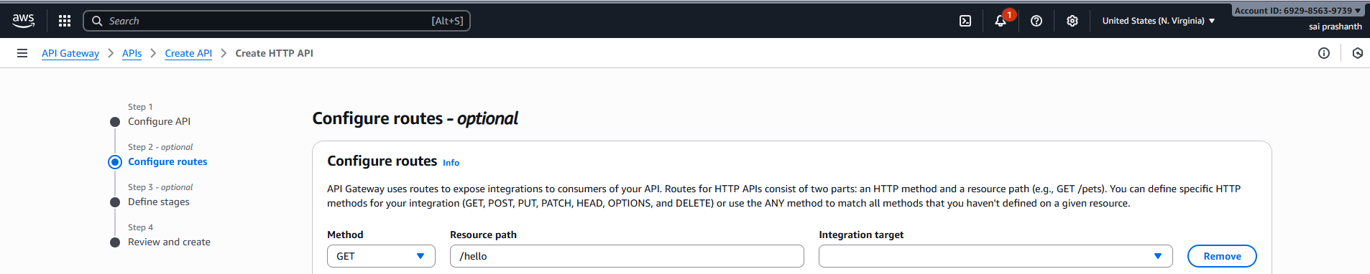
once you clicked create you can see API has been successfully created
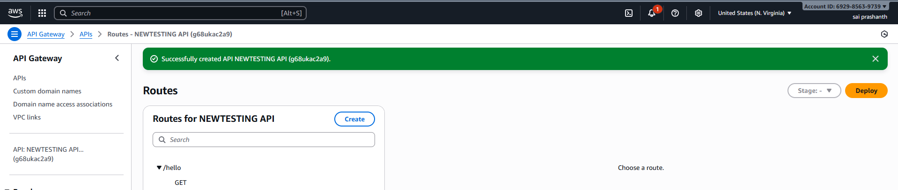
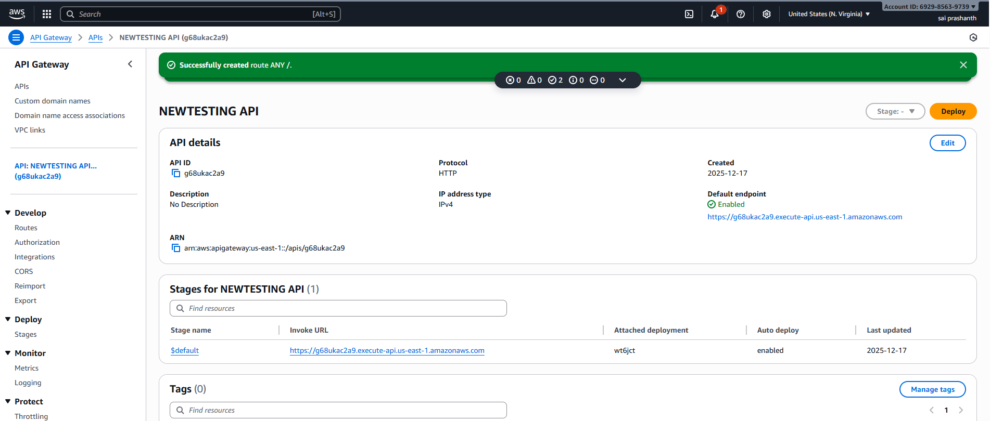
verification steps:
now check with the url
you can see the description with Hello from AWS Lambda
conclusion:
successfully linked lambda to API gateway
To create function URL
Objective: creating function url to view the link in browser
prerequisites:
aws
lambda
configurations
function URL
step by step process:
go to function URL—click on create function URL
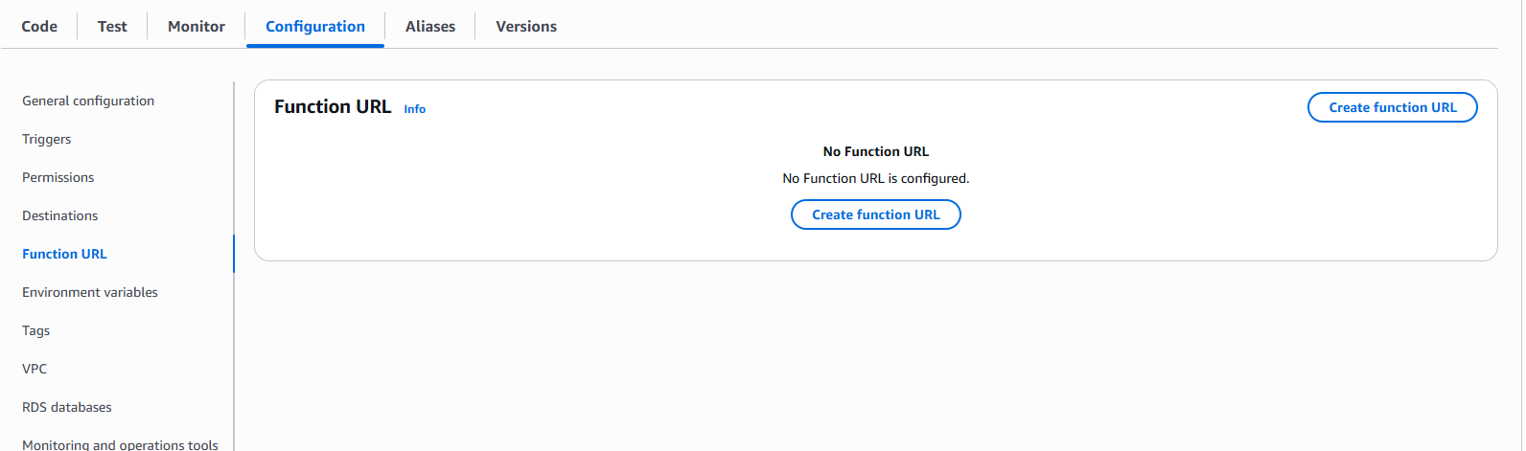
after clicking it—select auth type none—click on save
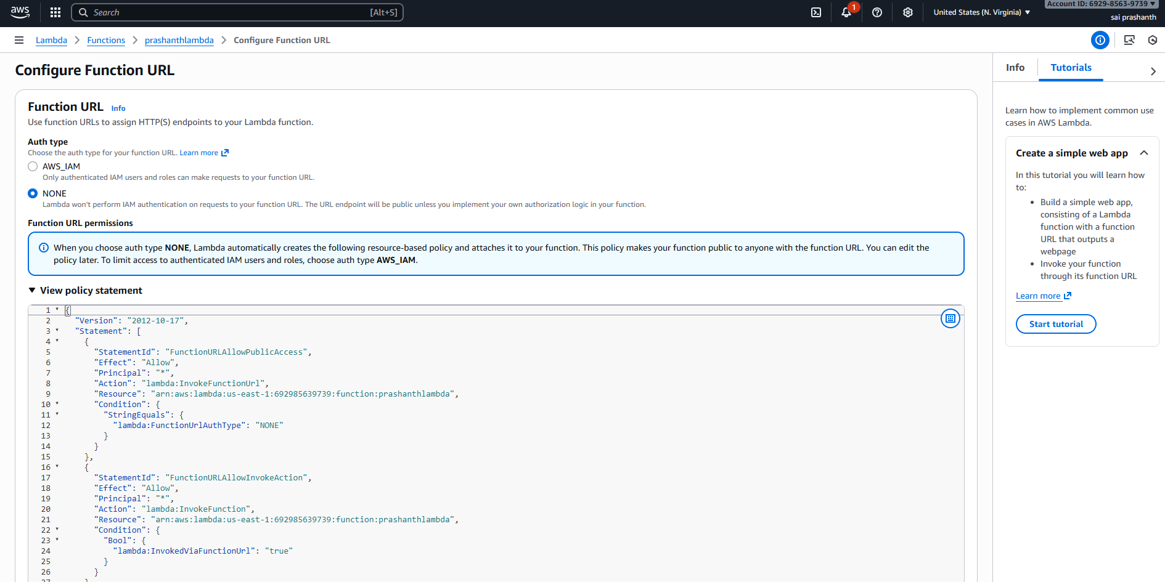
function URL has been created
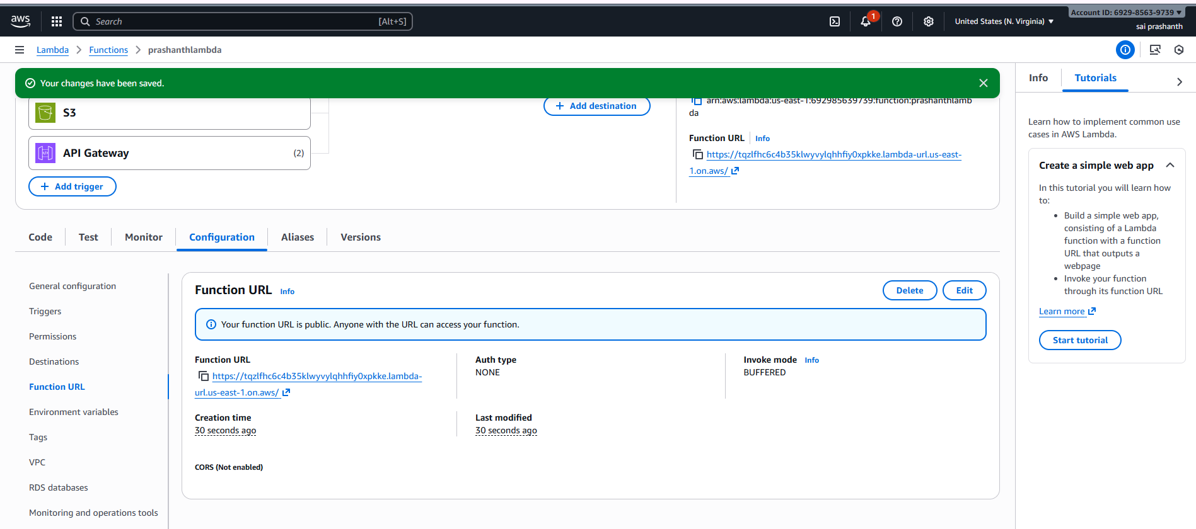
verification steps:
you can check with the URl
